 



Database Programming with SQL

* 1. : Updating Column Values and Deleting Rows Practice Activities

# Objectives

* + - Construct and execute an UPDATE statement
    - Construct and execute a DELETE statement
    - Construct and execute a query that uses a subquery to update and delete data from a table
    - Construct and execute a query that uses a correlated subquery to update and delete from a table
    - Explain how foreign-key and primary-key integrity constraints affect UPDATE and DELETE statements
    - Explain the purpose of the FOR UPDATE Clause in a SELECT statement

# Vocabulary

Identify the vocabulary word for each definition below.

|  |  |
| --- | --- |
| **UPDATE** | Modifies existing rows in a table |
| **correlated subquery update** | retrieves information from one table & uses the information to update another table |
| **Integrity Constraints** | Ensures that the data adheres to a predefined set of rules |
| **correlated subquery delete** | deletes information on a linked table based on what was deleted on the other table |
| **DELETE** | Removes existing rows from a table |

# Try It / Solve It

**NOTE: Copy tables in this section do not exist**

If any change is not possible, give an explanation as to why it is not possible.

1. Monique Tuttle, the manager of Global Fast Foods, sent a memo requesting an immediate change in prices. The price for a strawberry shake will be raised from $3.59 to $3.75, and the price for fries will increase to $1.20. Make these changes to the copy_f_food_items table.

CREATE TABLE copy_f_food_items

AS ( SELECT * FROM f_food_items);

UPDATE copy_f_food_items SET price = 3.75

WHERE LOWER(description) = 'strawberry shake';

UPDATE copy_f_food_items SET price = 1.20

WHERE LOWER(description) = 'fries';

SELECT * FROM copy_f_food_items;

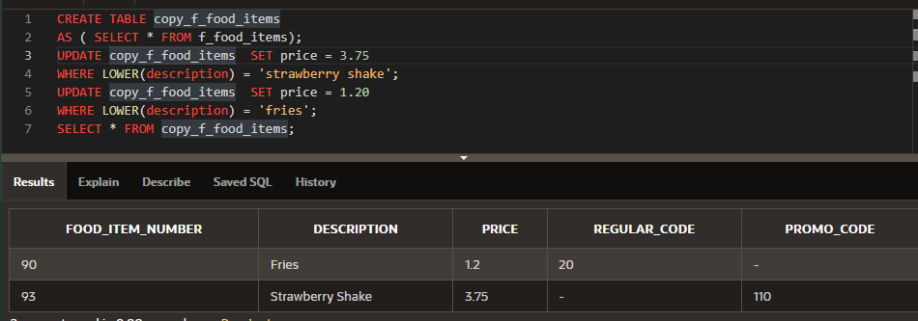

1. Bob Miller and Sue Doe have been outstanding employees at Global Fast Foods. Management has decided to reward them by increasing their overtime pay. Bob Miller will receive an additional

$0.75 per hour and Sue Doe will receive an additional $0.85 per hour. Update the copy_f_staffs table to show these new values. (Note: Bob Miller currently doesn’t get overtime pay. What function do you need to use to convert a null value to 0?)

CREATE TABLE copy_f_staffs

AS ( SELECT * FROM f_staffs);

UPDATE copy_f_staffs SET overtime_rate = NVL(overtime_rate, 0) + 0.75

WHERE LOWER(first_name || ' ' || last_name) = 'bob miller';

UPDATE copy_f_staffs SET overtime_rate = NVL(overtime_rate, 0) + 0.85

WHERE LOWER(first_name || ' ' || last_name) = 'sue doe';

SELECT * FROM copy_f_staffs;

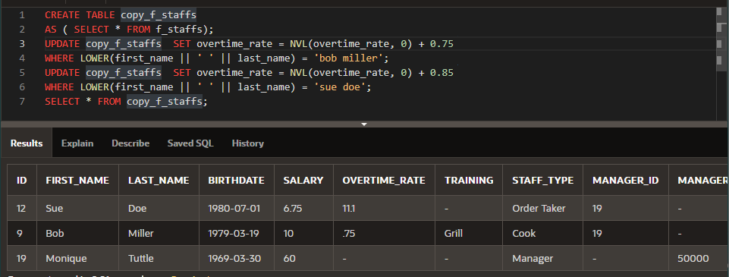

1. Add the orders shown to the Global Fast Foods copy_f_orders table:

|  |  |  |  |  |
| --- | --- | --- | --- | --- |
| ORDER_NUMBER | ORDER_DATE | ORDER_TOTAL | CUST_ID | STAFF_ID |
| 5680 | June 12, 2004 | 159.78 | 145 | 9 |
| 5691 | 09-23-2004 | 145.98 | 225 | 12 |
| 5701 | July 4, 2004 | 229.31 | 230 | 12 |

CREATE TABLE copy_f_orders

AS ( SELECT * FROM f_orders);

INSERT INTO copy_f_orders(order_number,order_date,order_total,cust_id,staff_id)

VALUES(5680,TO_DATE('June 12, 2004','fmMonth dd, yyyy'),159.78,145,9);

INSERT INTO copy_f_orders(order_number,order_date,order_total,cust_id,staff_id)

VALUES(5691,TO_DATE('09-23-2004','mm-dd-yyyy'),145.98,225,12);

INSERT INTO copy_f_orders(order_number,order_date,order_total,cust_id,staff_id)

VALUES(5701,TO_DATE('July 4, 2004','fmMonth dd, yyyy'),229.31,230,12);

SELECT * FROM copy_f_orders;

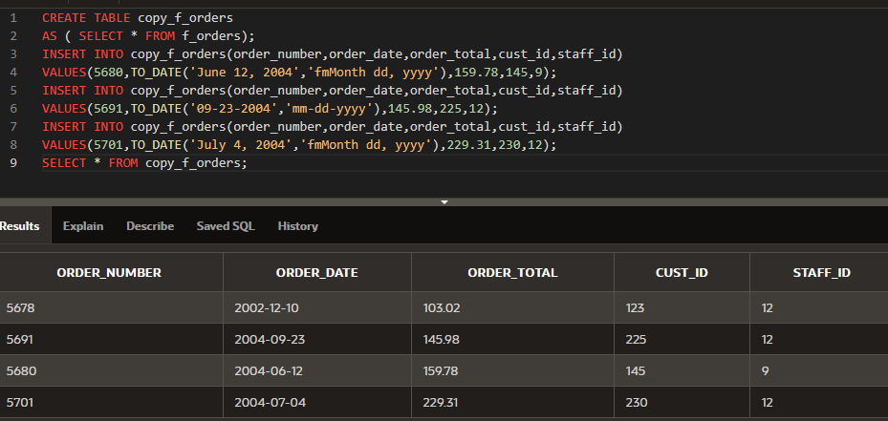

1. Add the new customers shown below to the copy_f_customers table. You may already have added Katie Hernandez. Will you be able to add all these records successfully?

|  |  |  |  |  |  |  |  |
| --- | --- | --- | --- | --- | --- | --- | --- |
| ID | FIRST_ NAME | LAST_ NAME | ADDRESS | CITY | STATE | ZIP | PHONE_NUMBER |
| 145 | Katie | Hernandez | 92 Chico Way | Los Angeles | CA | 98008 | 8586667641 |
| 225 | Daniel | Spode | 1923  Silverado | Denver | CO | 80219 | 7193343523 |
| 230 | Adam | Zurn | 5 Admiral Way | Seattle | WA |  | 4258879009 |

CREATE TABLE copy_f_customers

AS ( SELECT * FROM f_customers);

INSERT INTO copy_f_customers(id,first_name,last_name,address,city,state,zip,phone_number)

VALUES(145,'Katie','Hernandez','92 Chico Way','Los Angeles','CA',98008,'8586667641');

INSERT INTO copy_f_customers(id,first_name,last_name,address,city,state,zip,phone_number)

VALUES(225,'Daniel','Spode','1923 Silverado','Denver','CO',80219,'7193343523');

INSERT INTO copy_f_customers(id,first_name,last_name,address,city,state,zip,phone_number)

VALUES(230,'Adam','Zurn','5 Admiral Way','Seattle','WA',,'4258879009');

SELECT * FROM copy_f_customers;

ZIP поле не может быть нулем, поэтому третью строку нельзя вставить

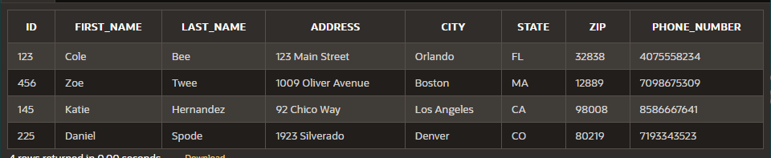

1. Sue Doe has been an outstanding Global Foods staff member and has been given a salary raise. She will now be paid the same as Bob Miller. Update her record in copy_f_staffs.

UPDATE copy_f_staffs SET salary = (SELECT salary FROM copy_f_staffs WHERE LOWER(first_name || ' ' || last_name) = 'bob miller')

WHERE LOWER(first_name || ' ' || last_name) = 'sue doe';

SELECT * from copy_f_staffs;

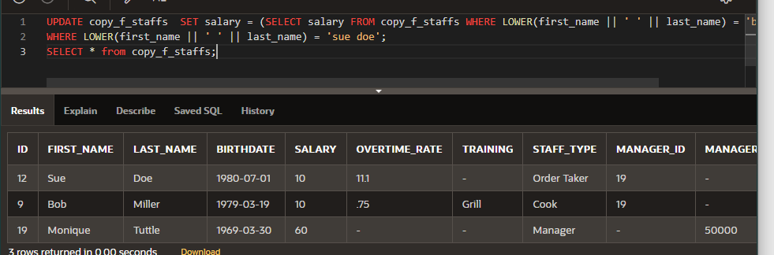

1. Global Fast Foods is expanding their staff. The manager, Monique Tuttle, has hired Kai Kim. Not all information is available at this time, but add the information shown here.

|  |  |  |  |  |  |
| --- | --- | --- | --- | --- | --- |
| ID | FIRST_NAME | LAST_NAME | BIRTHDATE | SALARY | STAFF_TYPE |
| 25 | Kai | Kim | 3-Nov-1988 | 6.75 | Order Taker |

INSERT INTO copy_f_staffs(id,first_name,last_name,birthdate,salary,overtime_rate,training,staff_type,manager_id,manager_budget,manager_target)

VALUES(25,'Kai','Kim',TO_DATE('03-Nov-1988','fmdd-Mon-yyyy'),6.75,NULL,NULL,'Order Taker',NULL,NULL,NULL);

SELECT * FROM copy_f_staffs;

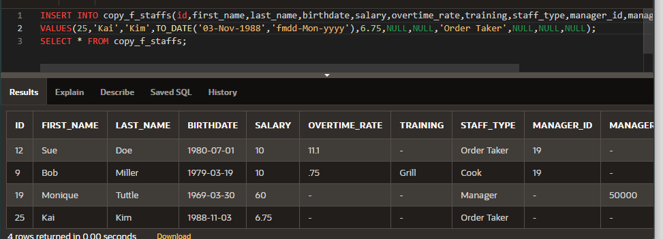

1. Now that all the information is available for Kai Kim, update his Global Fast Foods record to include the following: Kai will have the same manager as Sue Doe. He does not qualify for overtime. Leave the values for training, manager budget, and manager target as null.

UPDATE copy_f_staffs SET manager_id = (SELECT manager_id FROM copy_f_staffs WHERE LOWER(first_name || ' ' || last_name) = 'sue doe')

WHERE LOWER(first_name || ' ' || last_name) = 'kai kim';

SELECT * FROM copy_f_staffs;

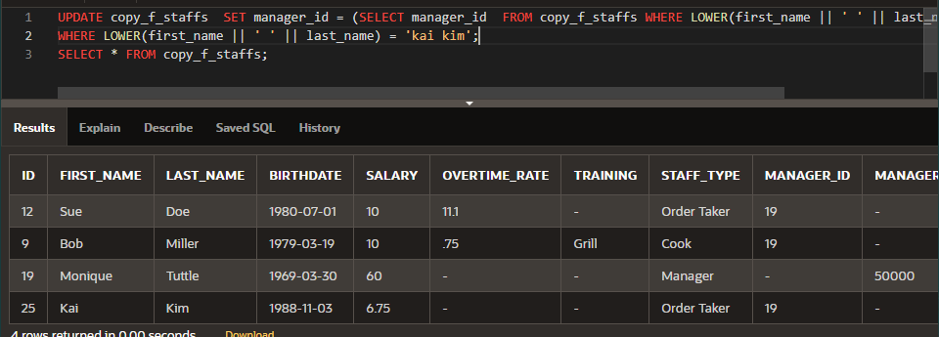

1. Execute the following SQL statement. Record your results.

DELETE from departments WHERE department_id = 60;

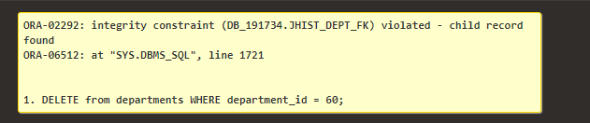

1. Kim Kai has decided to go back to college and does not have the time to work and go to school. Delete him from the Global Fast Foods staff. Verify that the change was made.

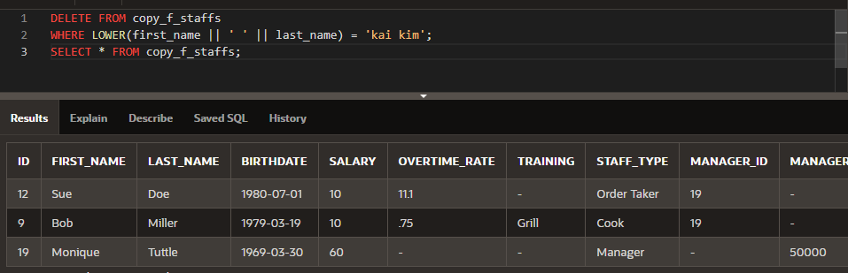

1. Create a copy of the employees table and call it lesson7_emp;

Once this table exists, write a correlated delete statement that will delete any employees from the lesson7_employees table that also exist in the job_history table.

CREATE TABLE lesson7_emp

AS ( SELECT * FROM employees);

DELETE FROM lesson7_emp

WHERE employee_id IN ( SELECT DISTINCT employee_id FROM job_history) ;

SELECT * FROM lesson7_emp

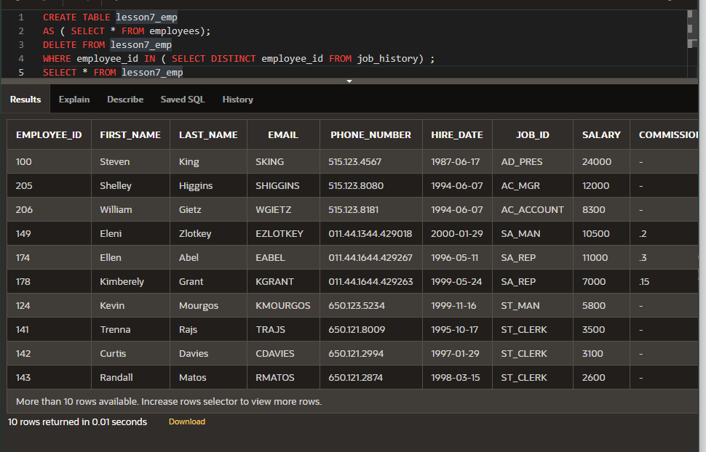

Copyright © 2020, Oracle and/or its affiliates. All rights reserved. Oracle and Java are registered trademarks of Oracle and/or its affiliates. Other names may be trademarks of their respective owners.